Lesson 7: Translating and Solving Equations
GETTING YOURSELF READY
Materials:  Mini whiteboards  Index Cards  Student Handout photocopies  Answers to Guided Practice completed and photocopied  Answers to last night’s Independent Practice completed and photocopied  Misconception to New Understanding Sheets  Scales, blocks, bag |  |  | Your Preparation:  Put last night’s Independent Practice Answer Key and the Misconception to New Understanding Worksheet on a table for students to pick up on their way in to class. |  | Agenda with times:  Do Now and Purpose: 5 minutes  Key Vocabulary: 3 minutes  Building the Skill: 15 minutes  Structured Practice: 15 minutes  Guided Practice: 10 minutes  Closure: 2 minutes
GETTING YOUR STUDENTS READY
*Do Now:
Use the answers to last night’s homework problems to correct your homework problems. If you got a 100%, you may write 100% on the top and turn it in. If you got any wrong, complete Misconception for a tricky problem.

Complete the Do Now Handout.
Objective: Today you will be able to solve addition, subtraction, multiplication and division equations |  |  |  | Proving Behavior: By solving equation word problems with 80% accuracy.
Purpose: When we solve problems, we often do not have all the numbers we need to solve the problem. We can use a variable to represent the unknown numbers and write an equation with the given information. Once we have an equation, we can solve it to determine our missing information. This is the real algebra stuff!!
Key Vocabulary: (from Glencoe.com)
Create vocabulary cards with these definitions and a picture to represent them and hang on the word wall. Use the cards to ask the students the given questions about the vocabulary and have them respond chorally or on their mini-whiteboards.
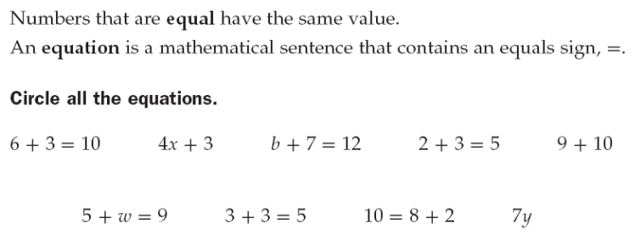
BUILDING THE SKILL
Solving Equations | Say/See: Think aloud problem 5. Emphasize that the equation is like a scale. You want to find the “weight” of the unknown, so you take equal weights off both sides to ensure the equation still holds.  Do: Have the students complete 6 with a partner and 7-10 on their own and show you their work, using the blocks.  Say/See: Show the students the numerical representation (subtraction, addition, “undoing”)  Do: Have the students use the same strategy to solve number 6 with a partner and 7-10 on their own and show you their work. Pair share: when you have an addition equation, what operation do you use to get the variable alone? Then, ask: What operation do you think you would use to get the variable alone if it were a subtraction equation? Multiplication? Division?  Say/See: Think aloud how to apply the idea of using the inverse operation to problem 1 of the next section. Identify that the inverse operation of the division is multiplication, so you would multiply each side by 8 to get the variable alone. I would also draw a block representation too.  Do: Have the students partner teach number 1 and fill in the work on their paper. Then, have them complete number 2 with a partner and numbers 3-8 on their own as a whiteboard drill.  Say/See: Teach the VIP: Solving One-Step Equations and show one step at a time for each type of equation.  Do: Have the students divide their whiteboards into four columns and record the following equations, one in each column: x + 22 = -12, x – 17 = 24, -4x = 12, x/4 = 12. Then after you say and show a step one of the equations, have them complete that step for their equation and show you their whiteboards. Then, have the students complete 1-4 of the addition/subtraction equations with a partner and 5-20 alone as a whiteboard drill. Then, have them complete 1-4 of the multiplication/division equations with a partner and 5-20 alone as a whiteboard drill. (They do not need to complete ALL these problems if you find they are understanding and are ready to move on.)  Say/See/Do: Examine 1-9 and have the students work with a partner and separate the problems into two categories of their choosing—they should look at what makes the problems different and how they would sort them. Then, show how some of the equations have variables that represent specific things and some are just variables. The ones that have variables that represent certain things are formulas and the others are equations.  Do: Have class chorally determine what is and isn’t a formula. Then whiteboard drill to make sure they can solve for each variable.
PRACTICING THE SKILL
*Structured Practice
Time: 5 minutes  Materials: Word Problems  Group Size: Pairs  Materials: Mini Whiteboards |  | There are two sets of word problems for the Structured/Guided Practice. Have the students complete the first problem of each section, one at a time, with a partner and hold up their whiteboards for you to see their answer. Because they are word problems, require the students to use their strategy of visualizing. They should draw some picture to represent the problem before solving. If the students are proficient, they may go on and use the remaining problems as their Guided Practice. If they need more help, you may do a whole class think aloud or give them another problem in the section to complete with a partner before releasing them to Guided Practice.
*Guided Practice (the proving behavior of the objective monitored by teacher)
Assignment: Guided Practice Handout. Have the students complete the remainder of the word problems. Make sure they show their visualization for each problem. |  |  |  |  |  | Criteria for Mastery: 80% of the remaining problems.
Explain Homework: Independent Practice Handout. Have students show their work and complete the problems.
*Closure: Have students complete the closure handout with a partner.

